Generated Visualization Outputs
Dataset 1: Customer Demographics
Visualization 1: Customer Age Distribution
The histogram shows that customer ages range from 18 to 70 years, with the highest concentration appearing around the mid-40s, particularly near ages 44–46. Other age ranges also have noticeable representation, although their frequencies vary. The distribution indicates that the dataset includes customers from a broad range of adult age groups, with a stronger concentration around middle-aged customers. This provides useful information about the demographic composition of FinMark's customer records and may support future customer segmentation analysis.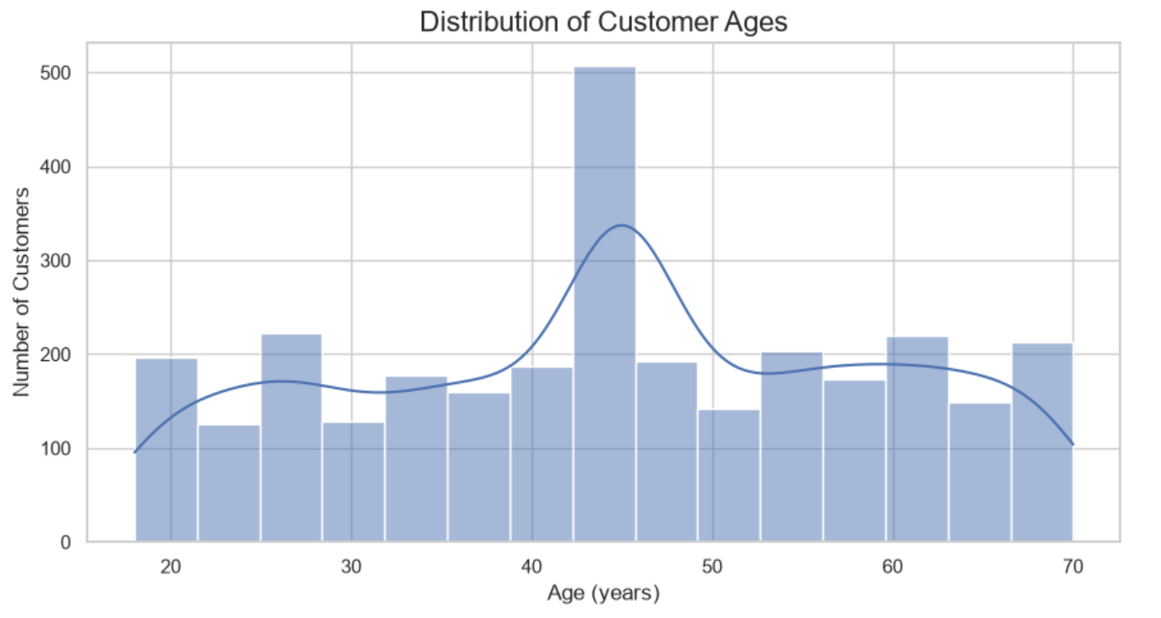
Key Observation:
The histogram shows that customer ages range from approximately 18 to 70 years. The largest concentration appears around the mid-40s, with the age group near 44–46 having the highest frequency. Other age ranges have relatively moderate numbers of customers, although there are some differences in frequency across the chart.
The distribution is not completely uniform because certain age ranges occur more frequently than others. This suggests that some age groups are more represented in the dataset. These patterns can help us understand the demographic composition of the customers and may be useful when exploring customer groups for future machine learning analysis.
Visualization 2: Customer Gender Distribution
This visualization compares the number of customers in each gender category. A bar chart makes the differences between categories easier to see and helps identify whether one group is more represented than the others.
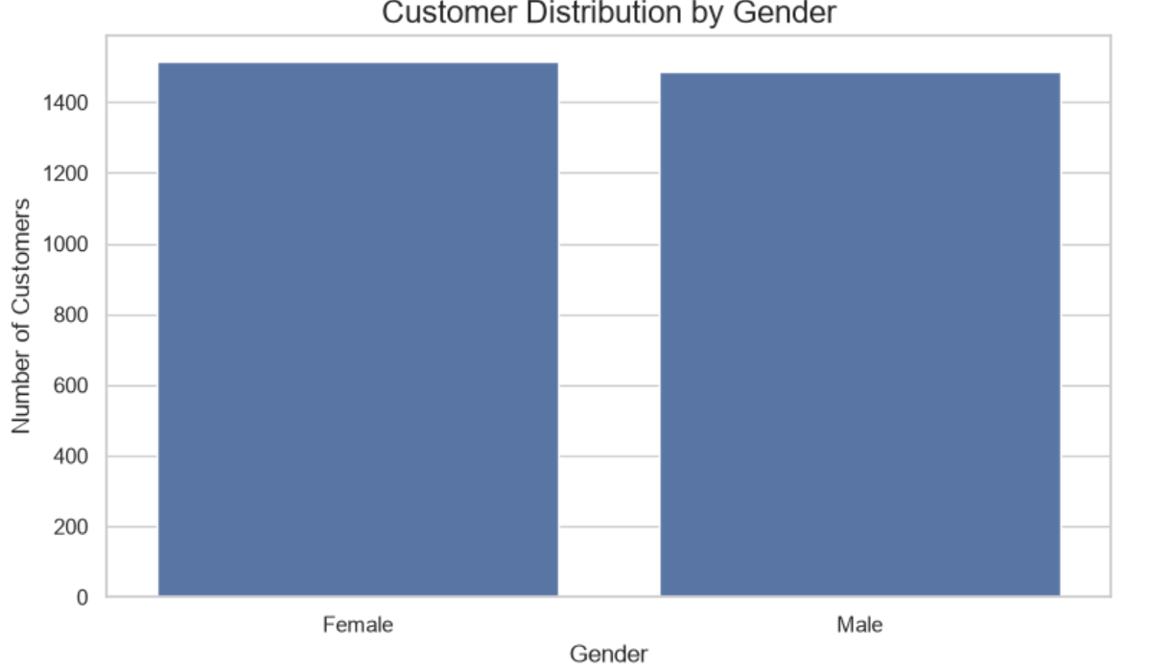
Key Observation:
The results show that the dataset contains 1,515 female customers and 1,485 male customers. Female customers make up approximately 50.5% of the records, while male customers account for 49.5%. The difference between the two groups is only 30 customers, indicating that the gender distribution is nearly balanced. This means that neither category strongly dominates the dataset, which provides a fairly even representation of both groups for further demographic analysis.

Visualization 3: Customer Age Spread and Potential Outliers
The box plot shows that customer ages range from approximately 18 to 70 years, with a median of 45 years. The middle 50% of customer ages fall between approximately 33.75 and 57 years. No separate points appear beyond the whiskers, indicating that the chart does not identify potential outliers using its default criteria. Overall, the age distribution shows a broad representation of adult customers without visibly isolated extreme values.
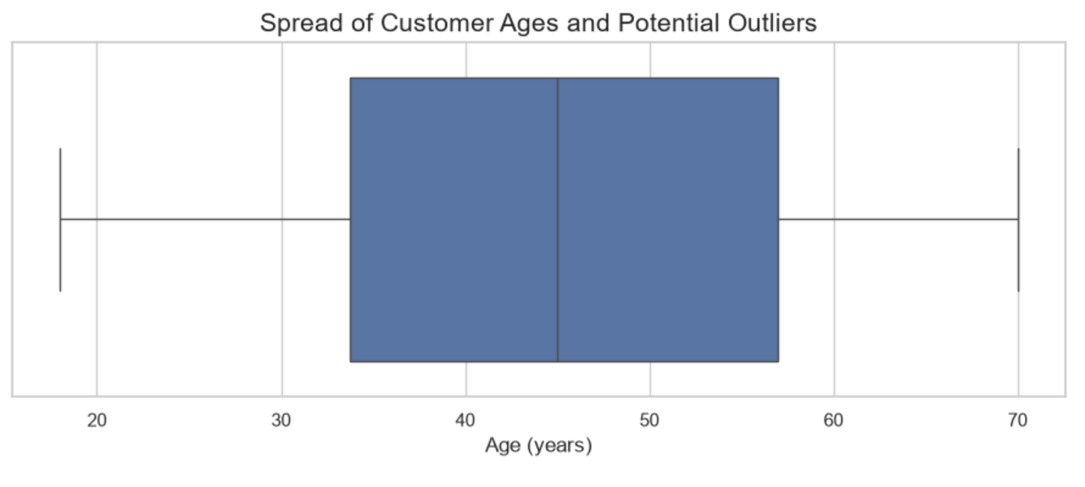Key Observation:
The box plot shows that customer ages range from approximately 18 to 70 years. The median age is around 45 years, meaning that half of the customers are younger than or equal to this age and the other half are older than or equal to it. The middle 50% of customer ages fall roughly between 34 and 57 years, showing a fairly wide spread in the dataset. No individual points appear beyond the whiskers, so the chart does not identify any potential outliers based on the box plot's default criteria. Overall, the dataset represents customers from a broad range of adult age groups.

Summary of Customer Demographics
The analysis shows that the Customer Demographics dataset contains 3,000 records, with no remaining missing values or exact duplicate rows. Customer ages range from 18 to 70 years, with an average age of 44.66 and a median of 45. The histogram shows a higher concentration around the mid-40s, while the boxplot does not identify separate outliers using its default criteria. The gender distribution is also nearly balanced, consisting of 1,515 female records and 1,485 male records.
These findings provide an initial understanding of the demographic characteristics represented in the dataset. Age and gender may serve as useful features for future customer segmentation when combined with transaction and social media information. The IncomeLevel field also contains an Unknown category, which should be considered during further data preparation and analysis.

Dataset 2: Customer Transactions
Visualization 1: Transaction Amount Distribution
The histogram illustrates the distribution of transaction amounts across the 3,015 records. The values are spread across a range of approximately 10 to 1,000, with a noticeable concentration around 500. This peak is likely influenced by the median imputation performed during preprocessing, where missing transaction amounts were replaced with the median value of the dataset. The visualization helps us understand the overall distribution of customer transaction amounts and identify patterns that may be relevant to further analysis.
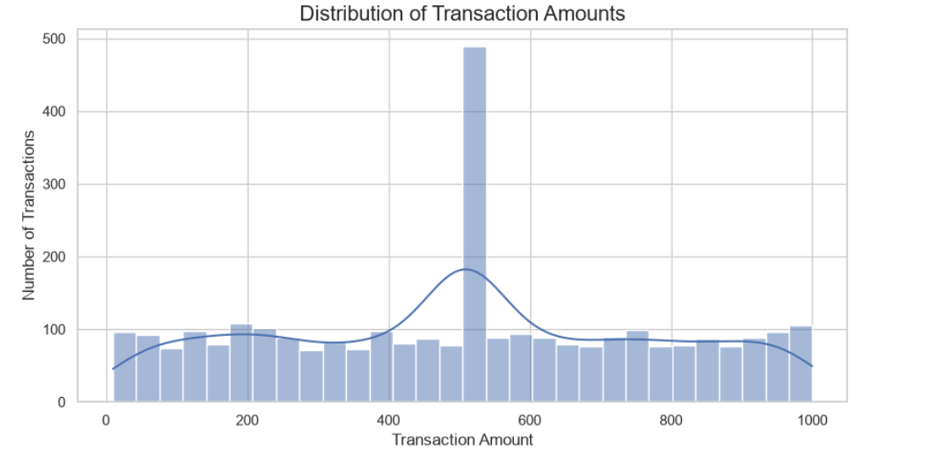
Key Observation:
Transaction amounts are distributed across the available range, but a prominent peak appears around 500. This concentration is consistent with the median value used to replace missing transaction amounts during preprocessing. Therefore, the peak should not automatically be interpreted as evidence that customers commonly make transactions of exactly this amount.

Visualization 2: Transaction Amount Outliers
The boxplot illustrates the distribution and spread of transaction amounts in the cleaned dataset. The median is approximately 508.07, while the middle 50% of transaction values fall between 282.02 and 720.39. The whiskers extend from approximately 10.03 to 999.86. No separate outlier points are displayed using the boxplot's default outlier criteria. This suggests that the transaction amounts do not contain statistically identified extreme values under this method.
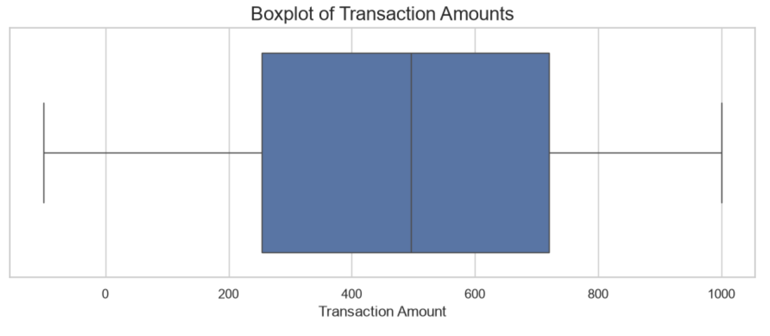Key Observation:
The boxplot shows that transaction amounts are widely distributed, with a median of approximately 508.07. The middle 50% of transactions range from 282.02 to 720.39. No separate outliers are visible based on the default boxplot criteria. However, this does not necessarily mean that all transaction values are normal or free from data-quality issues.

Visualization 3: Transactions by Product Category
This bar chart compares the number of transactions across the different product categories. Clothing has the highest transaction count, followed by Electronics. Automotive, Home & Garden, and Health & Beauty have relatively similar counts. The Unknown category has noticeably fewer transactions than the other categories. These results show that transaction activity is distributed across several product categories, although Clothing and Electronics have slightly higher counts.
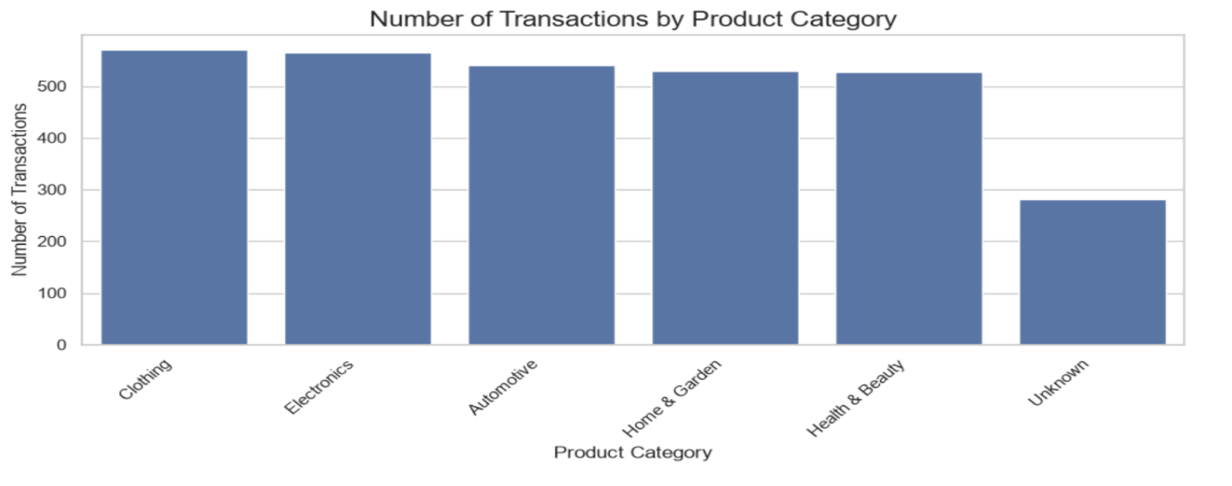
Key Observation:
Clothing and Electronics are the two most frequently recorded product categories. Automotive, Home & Garden, and Health & Beauty have relatively comparable transaction counts. The Unknown category has a lower count, indicating that some transactions do not have a specified product category. This missing category information should be considered in future customer behavior analysis and machine learning preparation.

Visualization 4: Transactions by Payment Method
This bar chart compares the frequency of transactions across the four available payment methods. Debit Card has the highest number of transactions, followed by Credit Card and PayPal. Bank Transfer has the lowest count. However, the differences between the four payment methods are relatively small, indicating that transaction activity is fairly balanced across the available payment options.
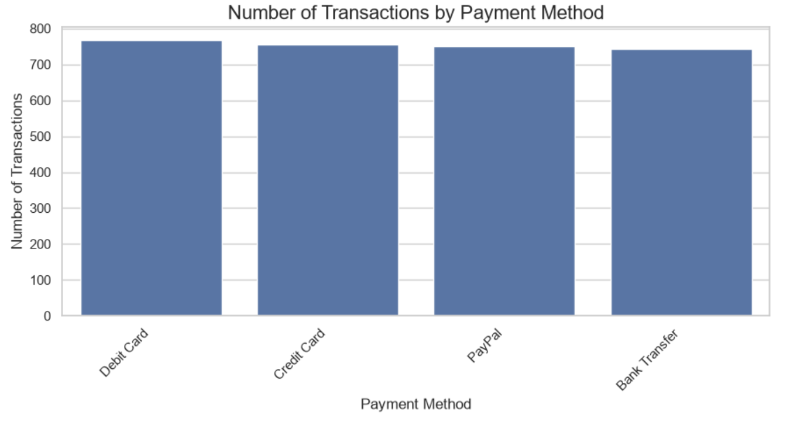
Key Observation:
Debit Card is the most frequently recorded payment method, while Bank Transfer has the lowest transaction count. Credit Card and PayPal also show similar levels of usage. Overall, the distribution suggests that customers use different payment methods without one option overwhelmingly dominating the others. These findings may help support future analysis of customer payment preferences.
Visualization 5: Monthly Transaction Trends
This line chart illustrates the monthly number of transactions from January 2022 to January 2025. Transaction activity was relatively low during the first half of 2022, with approximately 17 to 31 transactions per month. A substantial increase occurred around July 2022, followed by higher activity throughout 2023 and the first half of 2024. Monthly transactions fluctuated during this period, reaching a peak of approximately 142 transactions in August 2023. A sharp decline is visible beginning around July 2024, when monthly transactions dropped to approximately 29 and remained considerably lower through January 2025.
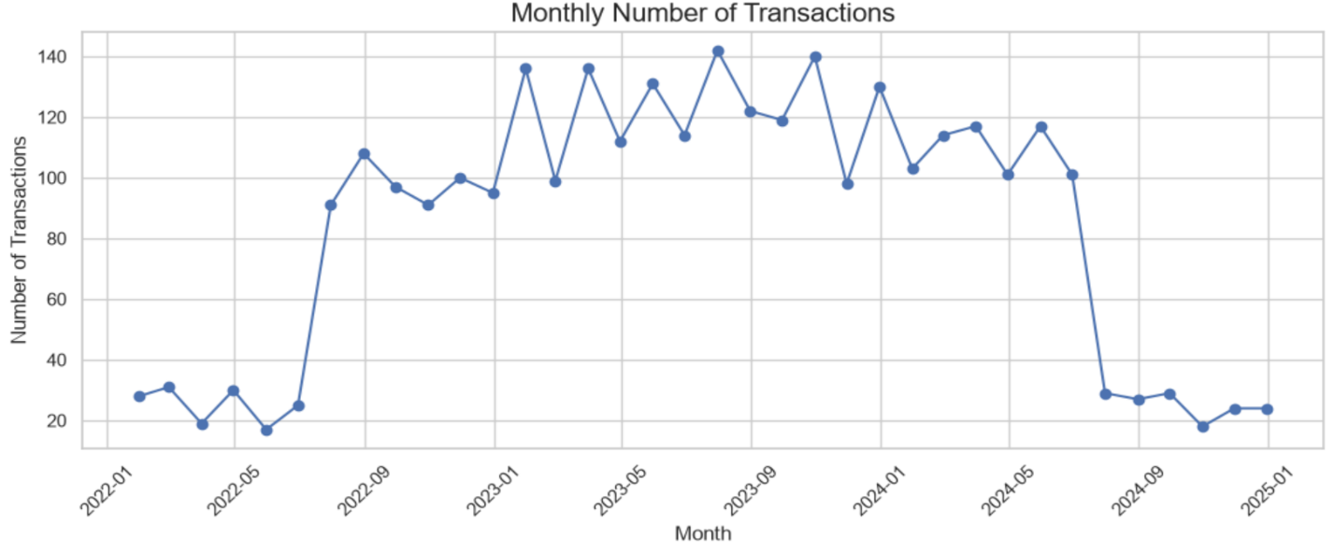
Key Observation:
The chart shows a noticeable change in transaction activity over the observed period. Monthly transactions increased significantly around July 2022 and remained relatively high throughout 2023 and the first half of 2024. However, transaction counts dropped sharply beginning in July 2024 and remained low through January 2025. This decline should be investigated further to determine whether it reflects an actual change in purchasing activity or incomplete transaction records. The pattern may be useful for future time-based customer behavior analysis.

Overall Findings and Machine Learning Relevance
The analysis shows that transaction amounts are widely distributed, with a median of approximately 508.07. Clothing and Electronics have the highest transaction counts, while the four payment methods show relatively similar levels of usage. The monthly transaction analysis also reveals increased activity from the second half of 2022 through the first half of 2024, followed by a sharp decline beginning in July 2024. These findings provide useful information for understanding customer purchasing behavior, product preferences, payment methods, and transaction patterns over time.
The cleaned dataset contains 3,015 transaction records, with no remaining missing values or exact duplicate rows. However, the Unknown product category and the sharp decline in monthly transaction counts should still be considered during further analysis. These findings can support future machine learning work, particularly customer segmentation and the identification of purchasing behavior patterns. Before modeling, the transaction data should be integrated with customer demographic and social media information using an appropriate customer-level aggregation process.

Dataset 3: Social Media Interactions
Visualization 1: Interactions by Platform
Our team will use a bar chart to compare the number of interactions recorded for each platform. This will help us identify the most represented platforms and determine how much of the dataset is labeled as Unknown.

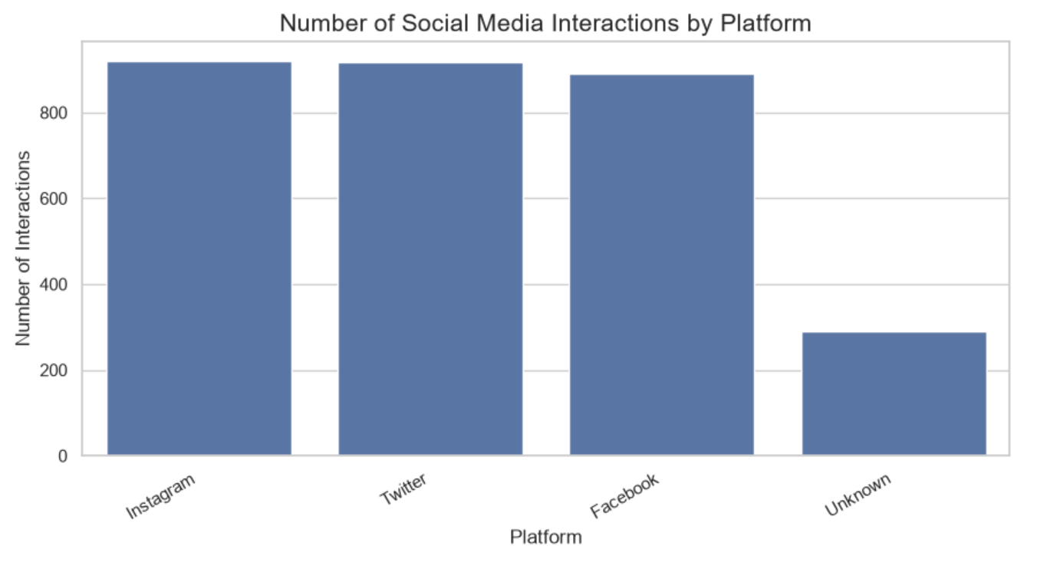
Key Observation:
The bar chart shows that Instagram has the highest number of recorded interactions, with Twitter following closely behind. Facebook also has a similar number of interactions, while the Unknown category has a noticeably lower count. The three identified platforms account for most of the records in the dataset. However, the Unknown entries should be considered when comparing platform activity because their original platform information is unspecified.

Visualization 2: Interaction Types
Our team will compare the frequency of likes, comments, and shares using a bar chart. This will help us identify the most common ways customers interact with social media content.

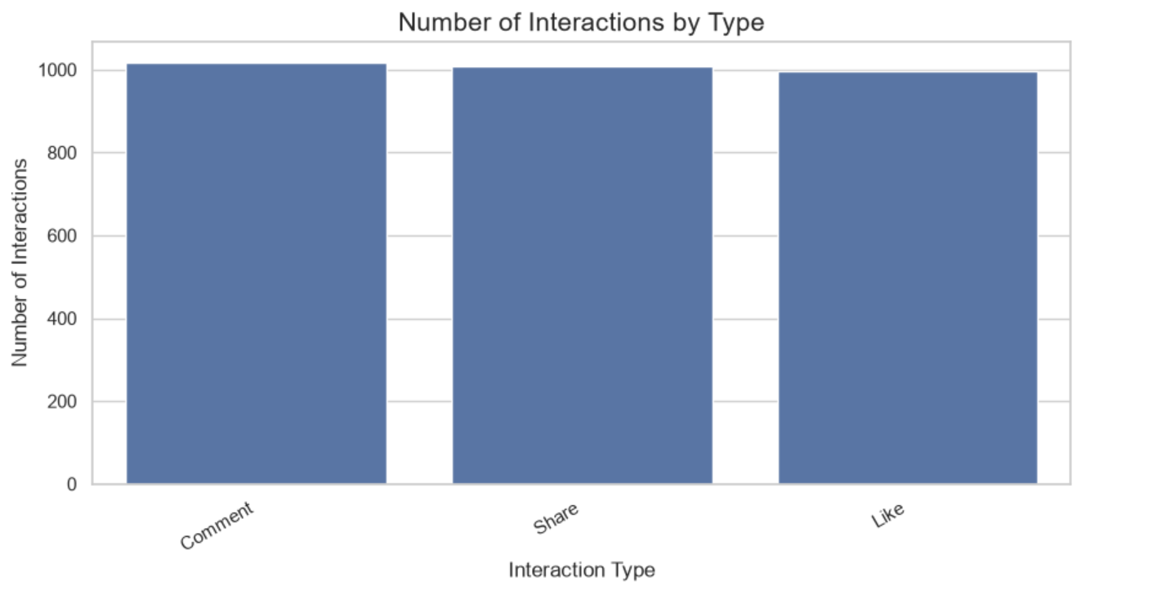Key Observation:
The bar chart shows that Comments have the highest number of recorded interactions, followed closely by Shares and Likes. However, the differences among the three interaction types are relatively small. This indicates that the dataset contains a fairly balanced distribution of these recorded engagement activities. These findings may help support future analysis of how customers interact with social media content.

Visualization 3: Sentiment Distribution
Our team will compare the frequency of all sentiment categories recorded in the dataset, including Positive, Neutral, Negative, Very Positive, Very Negative, and Unknown. This bar chart will help us understand the distribution of sentiment classifications and identify categories with fewer recorded interactions.
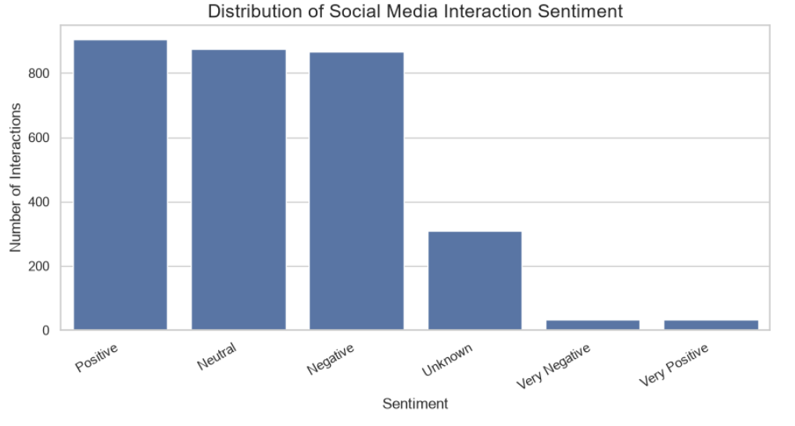
Key Observation:
The sentiment distribution shows that Positive sentiment has the highest count, with 905 records, followed by Neutral with 874 and Negative with 866. These three categories have relatively similar frequencies. The Unknown category contains 309 records, while Very Negative and Very Positive have only 34 and 32 records, respectively. This indicates that the dataset contains a mixture of sentiment classifications, although some interactions have unspecified sentiment information. The smaller counts in the extreme sentiment categories should also be considered when interpreting the overall distribution.

Visualization 4: Monthly Interaction Trends
Our team will examine the number of interactions recorded each month to identify changes in social media activity over time. This can help us recognize periods of higher or lower engagement and determine whether the dataset shows any noticeable trends 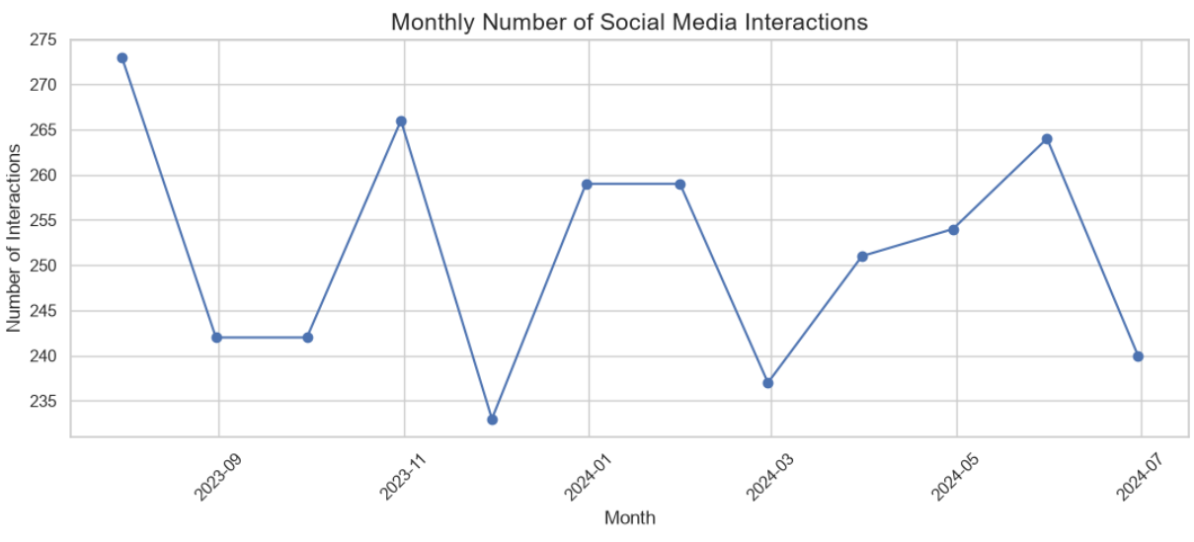
Key Observation:
The line chart shows that monthly social media interactions fluctuate between approximately 233 and 273 records throughout the observed period, from July 2023 to June 2024. Activity reaches its highest point around August 2023 and its lowest point around December 2023. The monthly counts increase and decrease at different points, indicating that social media interaction activity does not follow a consistent upward or downward trend. These patterns provide useful information about changes in recorded engagement, although additional information would be needed to explain the reasons for these fluctuations.

Overall Findings and Machine Learning Relevance
The analysis shows that Instagram, Twitter, and Facebook account for relatively similar numbers of recorded social media interactions, with Instagram having the highest count. Comments, Shares, and Likes are also distributed at relatively similar rates. Positive sentiment is the most common category, followed by Neutral and Negative, although the differences among these three categories are small. The monthly analysis shows fluctuations in interaction activity throughout the observed period, without a consistent upward or downward trend.
The cleaned dataset contains 3,020 records, with no remaining missing values or exact duplicate rows. However, the Unknown platform and sentiment categories should be considered during further data preparation. These findings may support future machine learning work involving customer segmentation, interaction patterns, and sentiment analysis. When integrating this dataset with customer demographics and transaction records, multiple social media interactions per customer should first be summarized at the customer level using CustomerID.

